Here are the files and texts to send regarding the 3D samples from ​the hotline...

If ​you are doing the $1000 day sale, I suggest they send the texts ​the day AFTER the sale to people that did NOT buy the set with the $1000 day sale. Then they can send the sample with the order:)

Also- It is MUCH cheaper to send the company samples than it is to fill the containers from amazon, since we can send with a regular stamp!

Happy Selling! The key is in the follow up.

**1ST TEXT TO CUSTOMERS:**

Hello Happy Customers! I am sure you have seen my emails and Facebook posts about how excited I am about the NEW Miracle Set 3D skin care line!!!! I have some FREE samples that I would love to send you if you are interested in trying it. I only have 15 samples of each formula, so the FIRST 15 to text me they have combo/oily skin and the FIRST 15 to text me they have normal/dry skin will get a sample!!! Just text back... I want a FREE sample! My skin is (combo/oily OR normal/dry) My address is... Then I will have my assistant send out ASAP!

**WHEN THEY REPLY:**

You got it! I will get it in the mail _____ This part is optional=[Head over to my Mary Kay facebook page and watch my live video from last night to hear more about it from me too. It will be REALLY helpful to hear the benefits and know how much to use! ]Comment on the post, so I know you watched it too!

**WHAT TO INCLUDE IN SAMPLE MAILING:**

Envelope/stamp

Timewise 3D sample

Info sheet on 3D set to wrap sample in- see attached

Coupon (optional)- see attached

* Once sample is wrapped in flier, fold in half and place in envelope with stamp

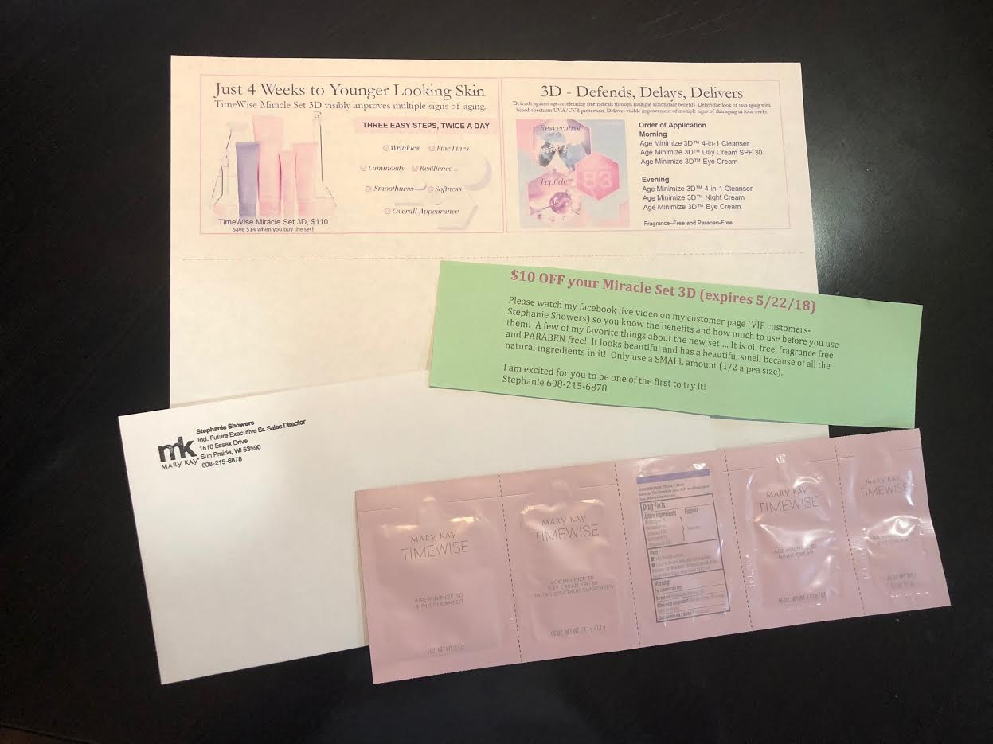

**TEXT when they should have received sample:**

Hey just wanted to check to see if you received your sample and see if you had a chance to try it out yet? :) I can't wait to see what you think about it! Stephanie

​**TEXT when they reply YES they have tried it:**

​

​Great! I hope you are loving it as much as I do:) How do you like the smell? How does your skin feel? Any questions for me? Stephanie

**TEXT if they haven't purchased the set yet (send ONE day before coupon expires):**

I just wanted to check in to see if you wanted to take advantage of the $10 coupon for the Miracle Set 3D! It is already discounted $14, so that would make it a $24 savings all together.